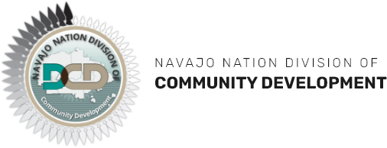

REQUEST FOR QUALIFICATION PROPOSALS FOR
ON-CALL BUILDING CODE INSPECTION SERVICES

RE-BID RFQ No. 24-03-3282GC

The Capital Project Management Department (CPMD) of the Navajo Nation Division of Community Development (NNDCD) welcomes all Licensed Building Code Inspection Contractors and/or Firms to provide a qualification proposal for On-Call Inspection Service for all Navajo Nation Construction under the oversight of NNDCD.

Detailed proposal package may be obtained from nndcd.org website and by emailing cpmd@nndcd.org. The NNDCD will receive sealed proposals until 4:00 P.M. on April 23, 2024

All questions regarding this RFQ proposal request shall be in writing by April 16, 2024 to Dwayne Waseta, Department Manager II at email cpmd@nndcd.org.

No Faxed e-mail proposal will be accepted. The NNDCD will be accepting in-person or post office/courier submission on any solicitation response for the RFQ.

